

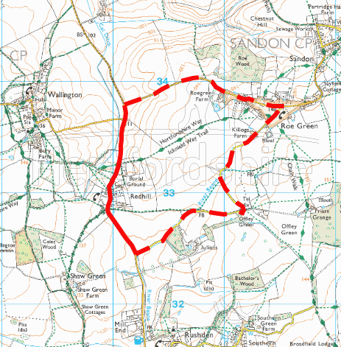
Redhill
Roe Green
Rushden Road
Rushden Road

Road Closure

Diversion

TEMPORARY TRAFFIC REGULATION ORDER

Redhill, Rushden
© Crown copyright and database rights 2021 Ordnance Survey 100019606
You are not permitted to copy, sub-licence, distribute or sell any of this data to third parties in any form. (This restriction may not apply to HCC and its licensed contractors, agents & partners.)

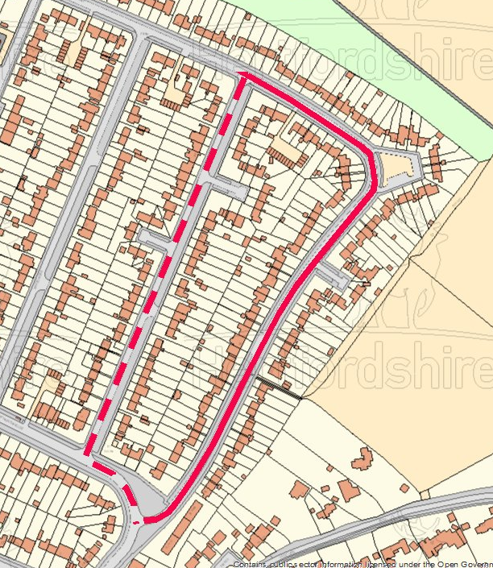
© Crown copyright and database rights 2021 Ordnance Survey 100019606
You are not permitted to copy, sub-licence, distribute or sell any of this data to third parties in any form. (This restriction may not apply to HCC and its licensed contractors, agents & partners.)
Eastern Way
Eastern Way
Maycroft
Northfields

Road Closure

Diversion

TEMPORARY TRAFFIC REGULATION ORDER

Eastern Way/Gaunts Way, Letchworth Garden City

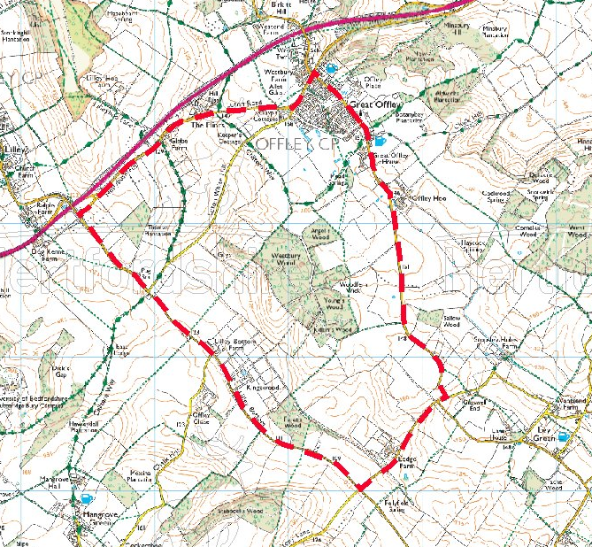
Kings Walden Road
High Street
Luton Road
Lilley Bottom
5U128 (unnamed road)
C25 (unnamed road)
Hoo Lane
Hollybush Hill

Road Closure

Diversion

TEMPORARY TRAFFIC REGULATION ORDER

Kings Walden Road, Offley
© Crown copyright and database rights 2021 Ordnance Survey 100019606
You are not permitted to copy, sub-licence, distribute or sell any of this data to third parties in any form. (This restriction may not apply to HCC and its licensed contractors, agents & partners.)

