

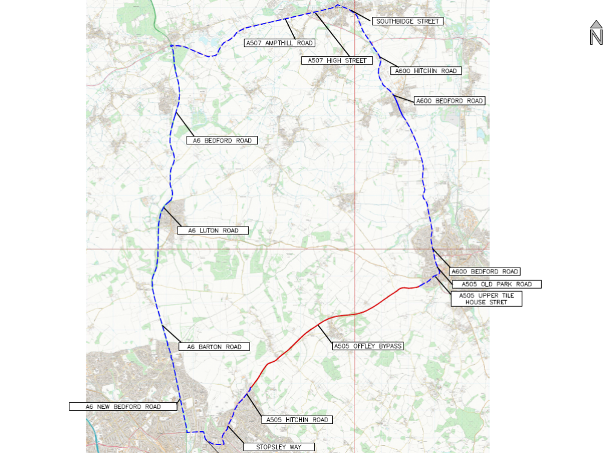
© Crown copyright and database rights 2021 Ordnance Survey 100019606
You are not permitted to copy, sub-licence, distribute or sell any of this data to third parties in any form. (This restriction may not apply to HCC and its licensed contractors, agents & partners.)
A505 OFFLEY ROAD
A505 MOORMEAD HILL
A505 STOPSLEY WAY
A5228 STOCKINGSTONE ROAD
A6 NEW BEDFORD ROAD
A507 (UNNAMED ROAD)
SOUTHBRIDGE STREET
CLIFTON STREET/HITCHIN ROAD
A500 BEDFORD ROAD
A505 PAYNES PARK ROAD

Road Closure
& Waiting Restrictions

Diversion

TEMPORARY TRAFFIC REGULATION ORDER

Various roads in Hitchin & Offley

